**SUPPLEMENTARY MATERIAL**

**Anastasia Santo**

**File.Sup.1 :** Filtered miRNas from the initial dataset (pvalue<0.1).

**File.sup.2** : The complete set of miRNAs had been converted in their respective target genes using the function get_multimir(). The resulting list had been used as a background for the functional enrichment analysis on DAVID.

**Sup.1** : PCA plot of reduced dataset.

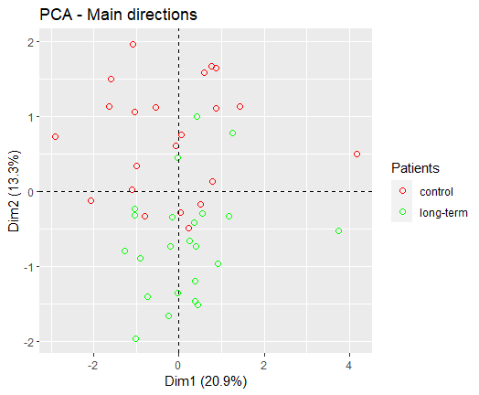

**Sup.2** : Screeplot PCA of reduced dataset.

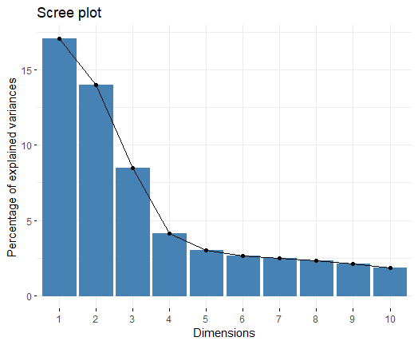

**Sup.3** : PCA plot of complete dataset.

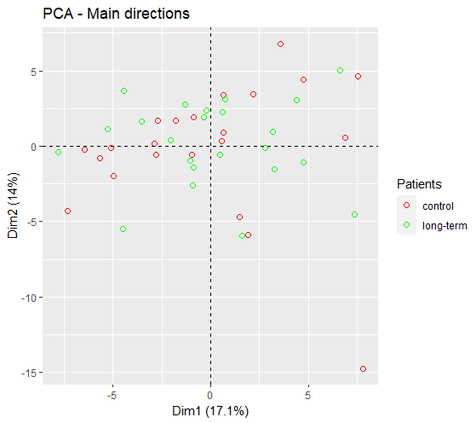

**Sup.4** : K-means plot of complete dataset.

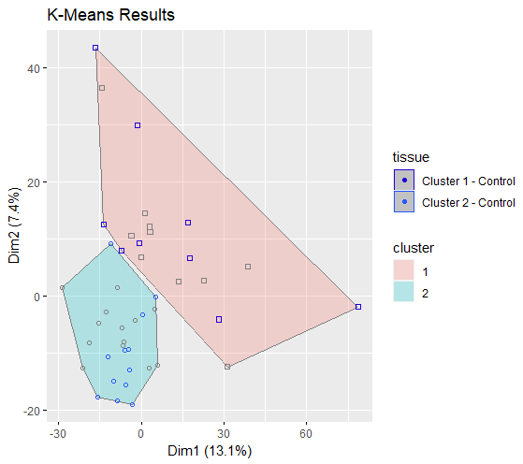

**Sup.5**: K-means plot of reduced dataset.

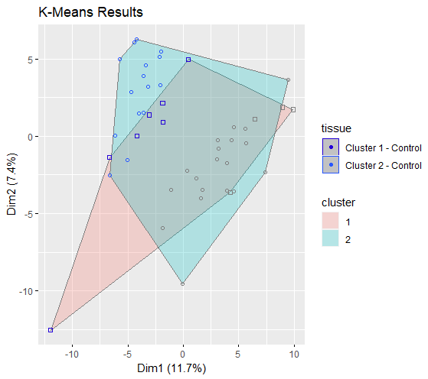

**Sup.6** : Boxplot of complete dataset of Control and Long Term patients.

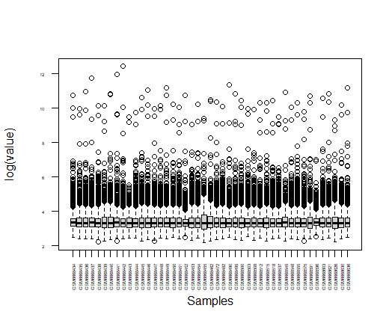

**Sup.7** : HeatMap of the 20 most significative miRNAs choosen by Random Forest.

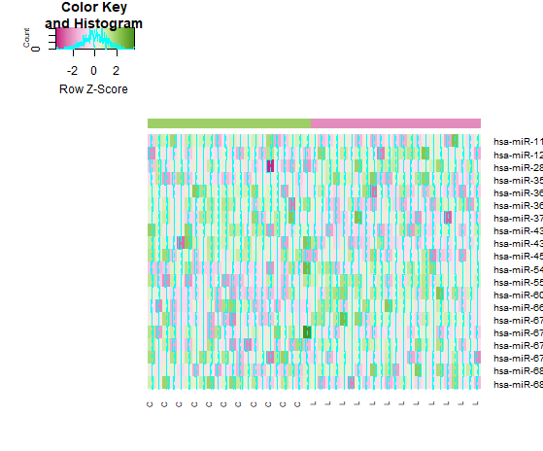

**Sup.8** : Random Forest Error plot (1); plot of miRNAs sorted by Mean Decrease Gini in Random Forest model (2).

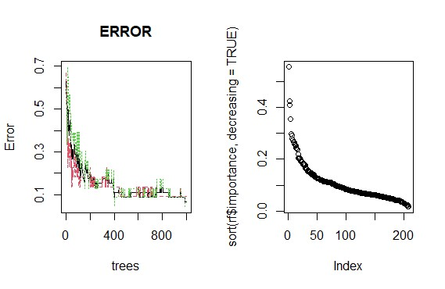

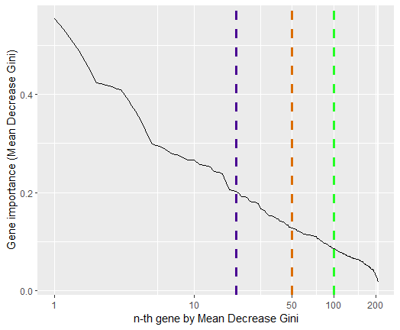

**Tab.Sup.1,2 :** In the first column we can find the up-regulated miRNAs target genes, while in the second column the down-regulated miRNAs target genes (next page).

|  |  |
| --- | --- |
| **MYB**  **BAI2**  **CTBP1**  **PSMC5**  **GOLGA6L2**  **NBPF10**  **MKRN3**  **SLC35G3**  **AC092067.1**  **LYPD3**  **RASGRP2**  **DOCK6**  **RBP5**  **TRAPPC4**  **SBSPON**  **TTC40**  **ASPA**  **SAMM50**  **KCNE2**  **FCAMR**  **C17orf75**  **E2F6**  **HSPA1L**  **TMEM211**  **PRTG**  **GPR45**  **TCP11**  **ZBTB46**  **CLIC1**  **LRRC27**  **URGCP**  **ACSF2**  **CCDC40**  **GRIK3**  **UNC93B1**  **BPI**  **O10D4_HUMAN**  **TTC18**  **TSPY2**  **C12orf44**  **SEC11A**  **IFNA5**  **PFKM**  **MYO1A**  **ACKR5**  **SLC24A2**  **TMEM39B**  **GSTT2B**  **GSTT2**  **RCVRN**  **SUPT20H**  **MAP3K12**  **ERICH1**  **NPIPB4**  **NPIPB5**  **THEM5**  **KCNH5**  **NCKAP1**  **ABHD2**  **EFNB2**  **GRIA2**  **ZNF521**  **MNT**  **RHOA**  **NREP**  **NLGN3**  **DTNB**  **STX1B**  **NNAT**  **CADM3**  **CTDSPL**  **TSHZ3**  **CALM1**  **ZC3H4**  **NR3C1**  **ADCYAP1**  **SOX10**  **CAMTA1**  **MED1**  **CTNND2**  **RBM14**  **TEX261**  **N4BP1**  **ATPAF1**  **G6PC3**  **KIAA0355**  **GPM6A**  **MTCP1**  **ADGRB2**  **AS3MT**  **FOXJ3**  **AC002451.1**  **NICN1**  **CCNG1**  **EN2**  **LMNB2**  **RAP1B**  **ST6GALNAC4**  **C18orf32**  **FUNDC2**  **P4HA1**  **ALDOA**  **SLC44A5**  **PRKRA**  **NFE2L2**  **ENY2**  **SLC52A2**  **SLC37A4** | **TCP1**  **SERF1A**  **SERF1B**  **ADAM19**  **KCNH7**  **ELK4**  **ESRRG**  **NFIB**  **FAM168B**  **TMTC4**  **LYZL1**  **VEZF1**  **MAP3K7**  **PGR**  **USP45**  **RBMY1A1**  **RBMY1A2**  **RPS16**  **LDHAL6B**  **DNMT1**  **ZNF101**  **PTPRK**  **PNLIPRP1**  **HSD17B7**  **CACNA2D3**  **JMJD7-PLA2G4B**  **TXNDC8**  **DDHD1**  **KMT2C**  **MLH1**  **NELFE**  **MICA**  **SI**  **C11orf82**  **EXO5**  **C9orf3**  **EMC7**  **SLCO6A1**  **CDKN3**  **FERMT2**  **DKK1**  **WTAP**  **RSBN1L**  **CCAR1**  **EPRS**  **TOP1**  **HOXD8**  **PRDM8**  **MSANTD3**  **GPC5**  **UBE2B**  **DPP8**  **C4orf29**  **CCDC138**  **SCG2**  **EIF3E**  **HAND2**  **ZNF440**  **CROT**  **GLIS3**  **ZNF827**  **CPEB2**  **HIPK1**  **YOD1**  **TENM1**  **AUTS2**  **LATS2**  **KCNMB2**  **CAPZA1**  **BACH2**  **DENND1B**  **PPHLN1**  **ANK3**  **SKI**  **ZFYVE16**  **PLAGL2**  **ONECUT2**  **MECP2**  **KCNMA1**  **XPOT**  **HS2ST1**  **DCAF12**  **XKR4**  **ZNF292**  **IRF2**  **GGACT**  **MAPK8**  **APOC2**  **CREM**  **TBC1D19**  **DPH3**  **ZNF77**  **DCAF6**  **ATP6V0C**  **STARD3NL**  **PRDM4**  **FMR1**  **FBXO48**  **SPATA6L**  **MARCHF5**  **MBD2**  **ATP23**  **MBD4**  **LEFTY1**  **BTG1**  **ZNF501**  **ASF1A**  **FGF16**  **TSEN34**  **SMIM19**  **MCCD1**  **NOL7**  **DYRK4**  **GRIK1-AS2** |

**Sup.9 :** David functional enrichment analysis on down-regulated miRNAs target genes.

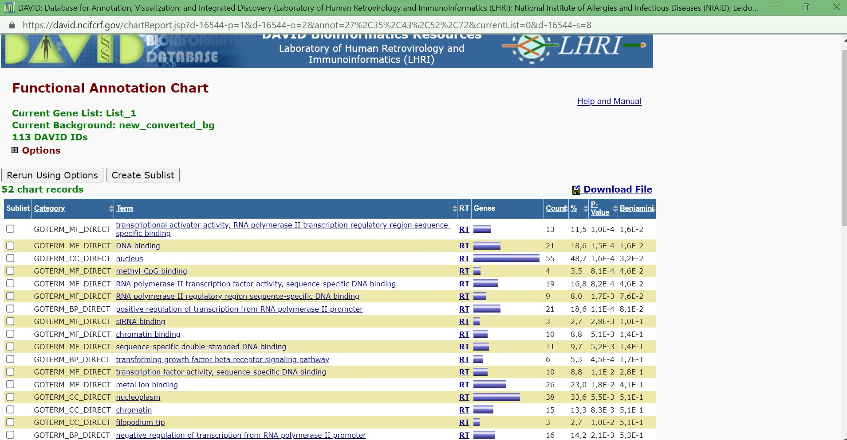

**Sup.10** : EnrichNET analysis on up-regulated miRNAs target-genes.

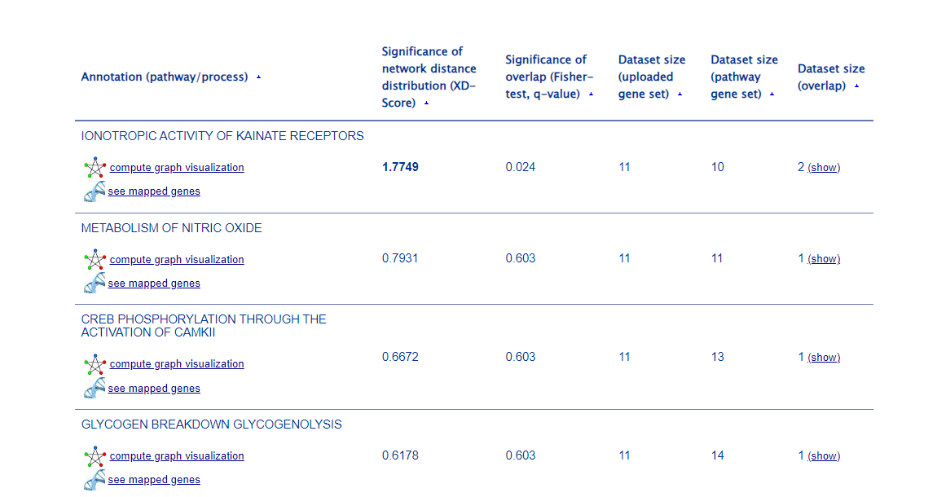

**Sup.11** : G.profiler functional enrichment analysis on down-regulated miRNAs target –genes.

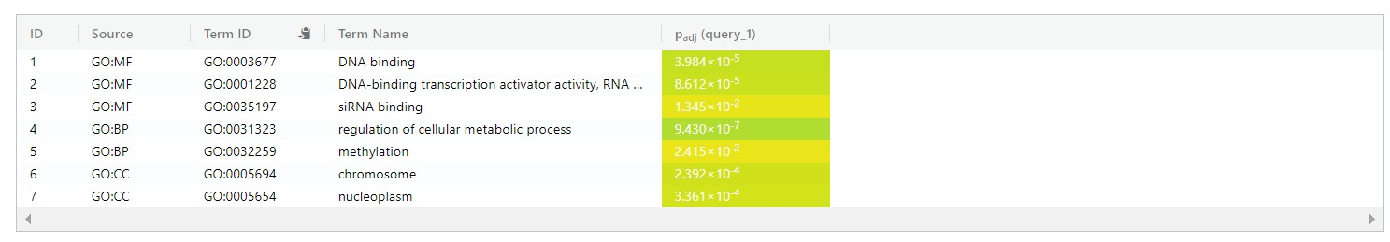

**Sup.12** : G.profiler plot of up and down regulate miRNAs target-genes functional enrichment analysis.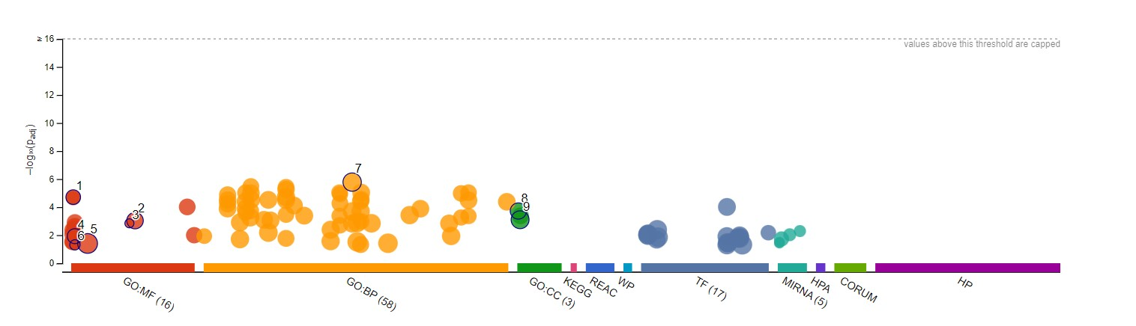

**Sup.13** : String graph of the most enriched genes of the up-regulated miRNAs target-genes. In Yellow we can see the genes correlated with the detection of calcium ion; in Red we can see the genes correlated with the Activation of Ca-permeable Kainate Receptor; in Blue we can see genes correlated with the Sodium/Calcium exchangers.

